CubeSat Subsystems Sketch Template

Download and print this template for your team's collaboration. Use it to brainstorm the different components of the proposed CubeSat prototype with short descriptions (1-2 sentences). You may upload a .doc, .pdf, or .ppt of the completed template in response to the “Subsystems sketch” field of the mission proposal.

 | Communication and data storage
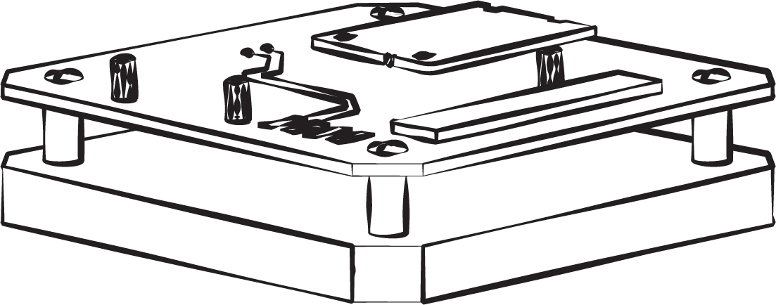 | Computing and payload
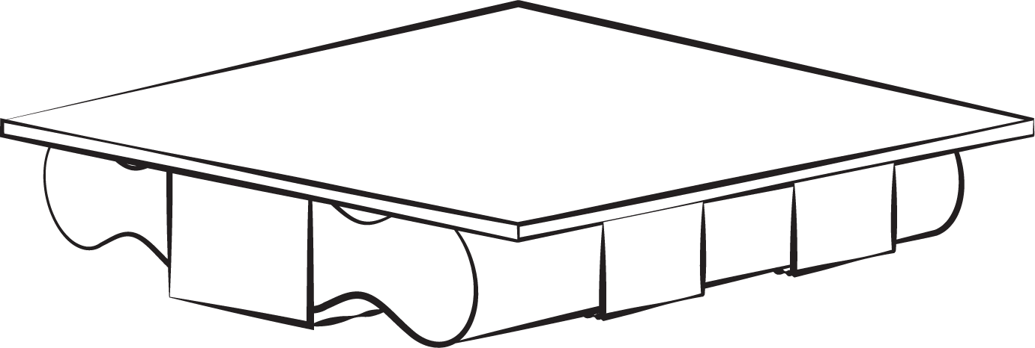 | Power
 | Structure

Launch

